**CASE STUDY TERM PROJECT**

**HP – Customer Relationship Management (CRM)**

**System Integration (COMP 321 - Sec.001)**

**Prof. Peter Bhola**

**Prepared by:**

**Sagarkumar Patel (300853316)**

**Brief Description about HP.**

HP is a technology company that operates in more than 170 countries around the world. It is the trading name for Hobbs Parker 2000 Limited and is part of the Hobbs Parker Group. HP investigate how innovation and administrations can help individuals and organizations address their issues and challenges, and understand their potential outcomes, yearnings and dreams. HP apply new thinking and thoughts to make more straightforward, important and confided in encounters with innovation, consistently enhancing the way our clients live and work.

No other organization offers as total an innovation item portfolio as HP. HP give framework and business offerings that traverse from handheld gadgets to a portion of the world's most capable supercomputer establishments. HP offer shoppers an extensive variety of items and administrations from advanced photography to computerized excitement and from figuring to home printing. This extensive portfolio helps hp coordinate the correct items, administrations and answers for our clients' particular needs.

**Brief History.**

Stanford University classmates Bill Hewlett and Dave Packard founded HP in 1939. The company's first product, built in a Palo Alto garage, was an audio oscillator—an electronic test instrument used by sound engineers. One of HP's first customers was Walt Disney Studios, which purchased eight oscillators to develop and test an innovative sound system for the movie Fantasia.

**Oracle’s Siebel Introduction.**

Oracle's Siebel Customer Relationship Management (CRM), is the world's most complete CRM solution, helps organizations achieve maximum top- and bottom-line growth. (**Note**: Top line growth - A company's bottom line can also be referred to as net earnings or net profits. Bottom line growth – The top line refers to a company's gross sales or revenues.)

Siebel CRM plays an important role within the Oracle Customer Experience (CX) portfolio, delivering customer experience across mobile, in-store, and field service, and leveraging a wide range of Oracle foundation tools.

HP expects to save millions of dollars in IT costs, by installing Siebel’s CRM system and creates a single view of its customers by implementing sales, marketing and partner management application from Siebel Systems Inc.

**Siebel Sales Application.**

Oracle's Siebel Sales applications maximize sales effectiveness in real time by accelerating the quote-to-cash process, aligning sales channels, increasing pipeline and win rates, and raising average transaction values.

Siebel Sales makes customer interaction possible by providing easy access to all stakeholders, allowing them to anticipate customer needs, improve responsiveness, enhance customer satisfaction, and increase loyalty.

**Siebel Enterprise Marketing.**

Oracle's Siebel Enterprise Marketing is a comprehensive closed-loop solution that empowers B2B and B2C organizations across industries to achieve excellence in marketing. Tailored to the needs of business and consumer marketers across more than 20 industries, the Siebel Enterprise Marketing Suite delivers actionable insight to all members of the marketing organization.

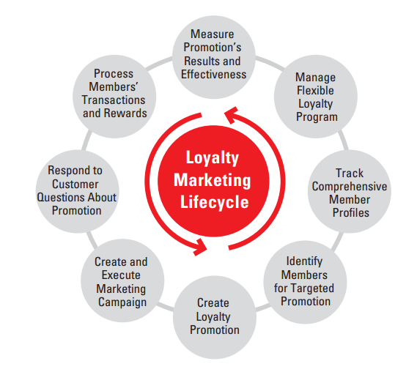

**Siebel Social.**

Siebel CRM provides an open integrated framework for Social Media giving customers the ability to use Oracle Social Relationship Management (SRM) cloud services with their Siebel CRM implementation.

* **Social Customer Service.**

Easily route and respond to customer service issues from social networks within existing customer support platform.

Automatically route to appropriate agent for fast response.

* **Social Marketing.**

Create Social Marketing Campaigns and link to Siebel Marketing.

Create Social Marketing campaigns and Facebook pages social lead generation.

* **Contact Social Profiles.**

Automatic creation of Social Media profiles for Contacts from Lead capture and Service.

For individual Contacts, view and store many social media profiles.

For each social media profile, view and store detailed profile and attribute data into Siebel.

Provide a complete enhanced 360-degree view of a Contact in Siebel CRM.

**IT planning strategy & e-business model.**

HP defines its enterprise strategies by felicitating these important aspects of its own organization:

* Right Information, Processes and Tools.
* Need for Visibility, Consistency and Integration.
* Multi-Vendor Management.
* Maximum Contact Center Performance.

Few high-level pragmatic approach when it comes to defining enterprise systems strategy can be taken into consideration.

* Current organizational structure
* Applications inventory
* System architecture diagrams
* Current and multi-year IT budget
* SLAs between IT and internal customers
* Key performance indicators

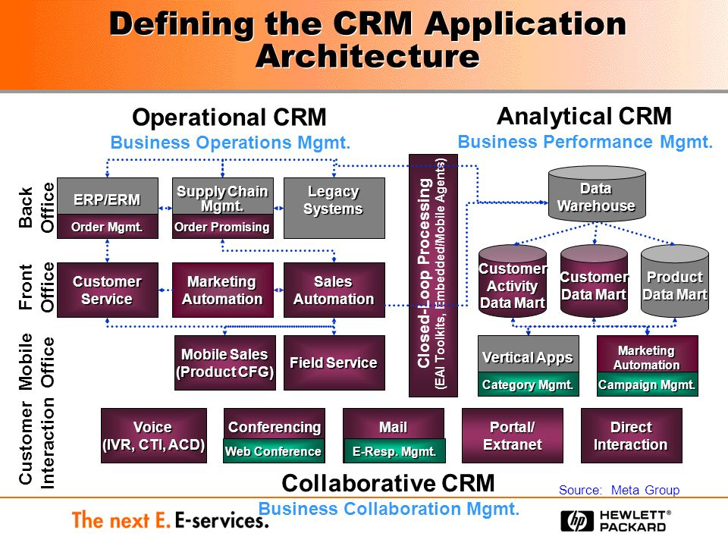

**HP Collaborative CRM Architecture.**

**Use Case for Order Replacement.**

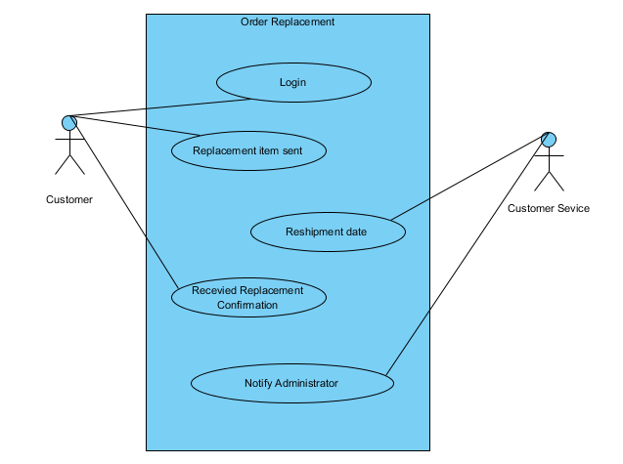

**Work Flow Chart for the Use Case.**

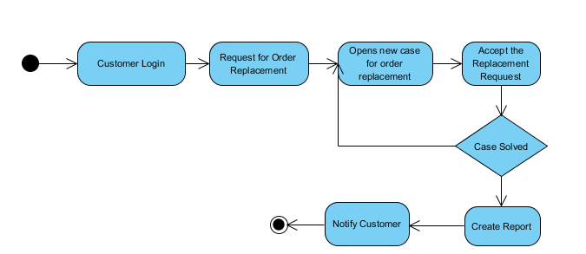

YES

NO

**Customer Information for Order Replacement.**

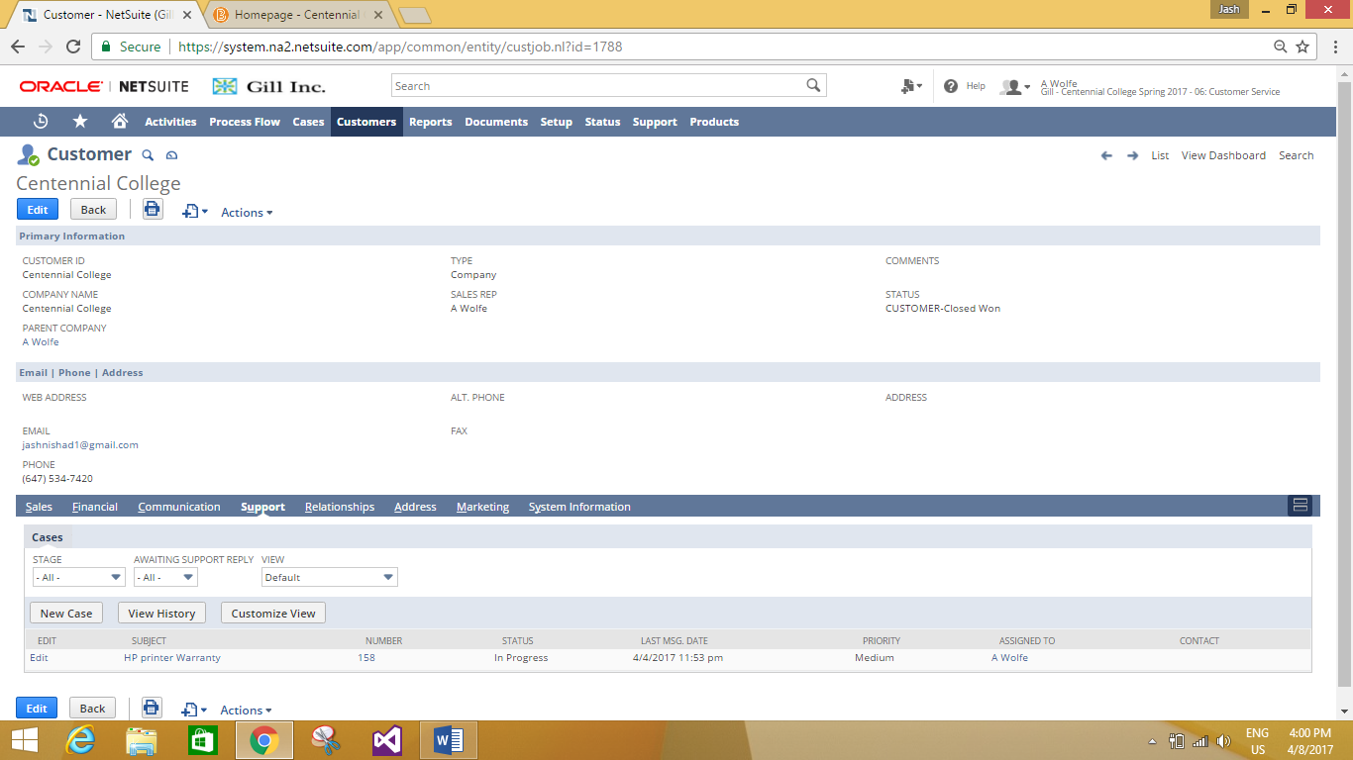

**Creating Case for Customer’s Order Replacement.**

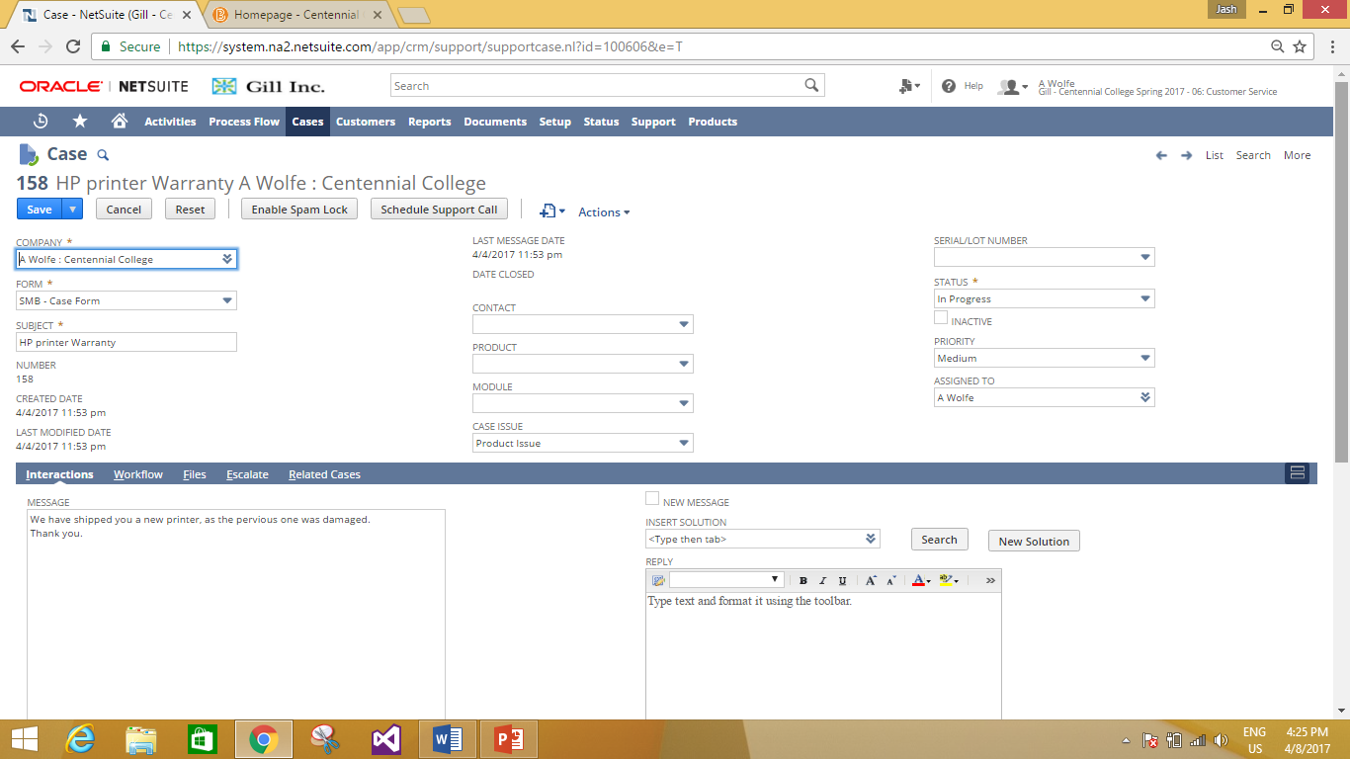

**Customer’s Primary Information.**

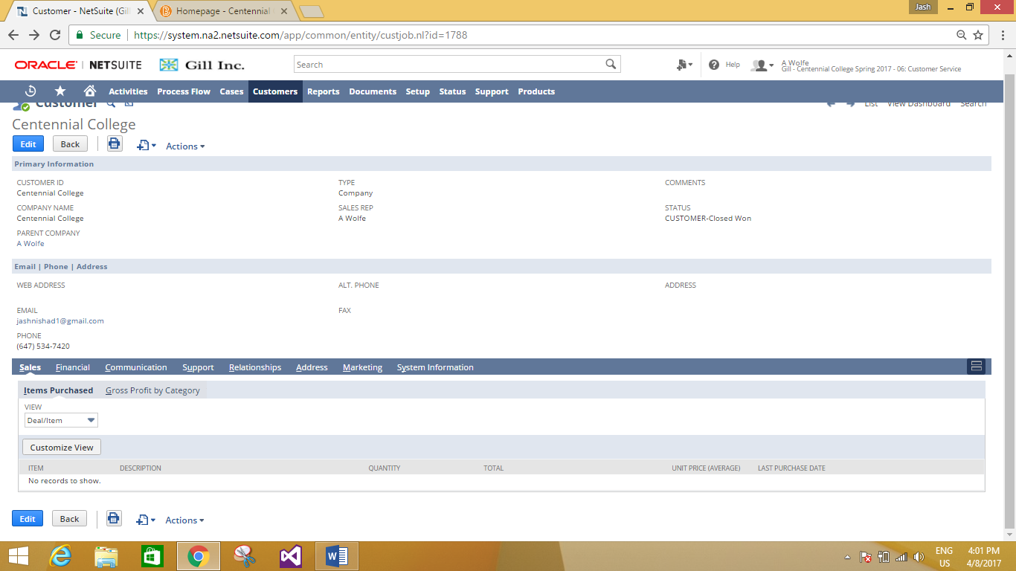

**Sales Information Tab.**

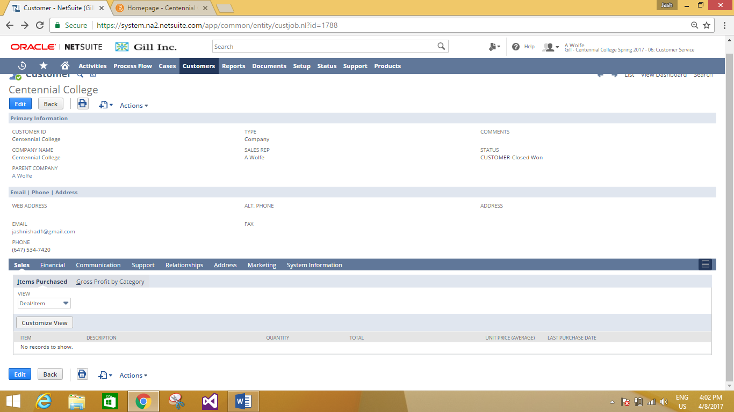

**Communication Tab.**

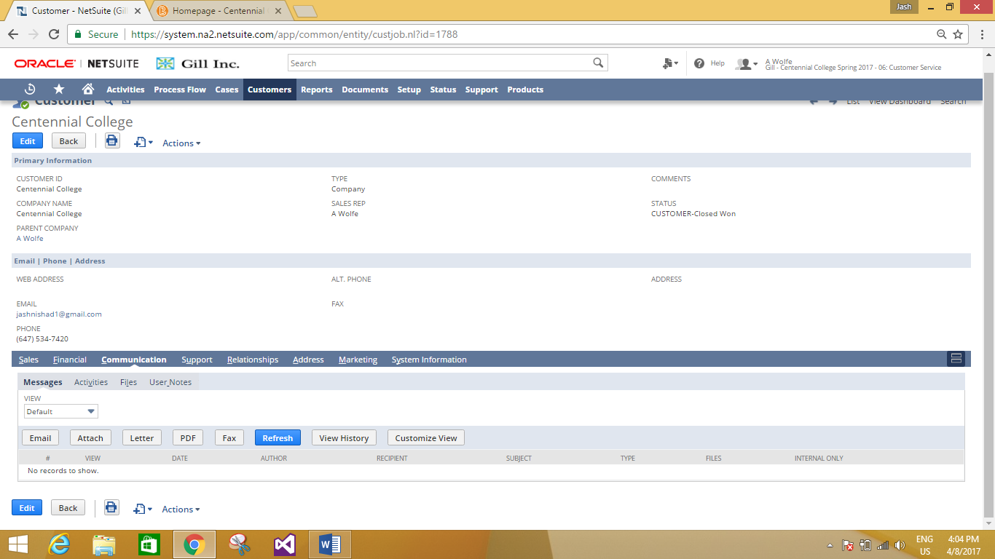

**Example: Customer can be notified through email.**

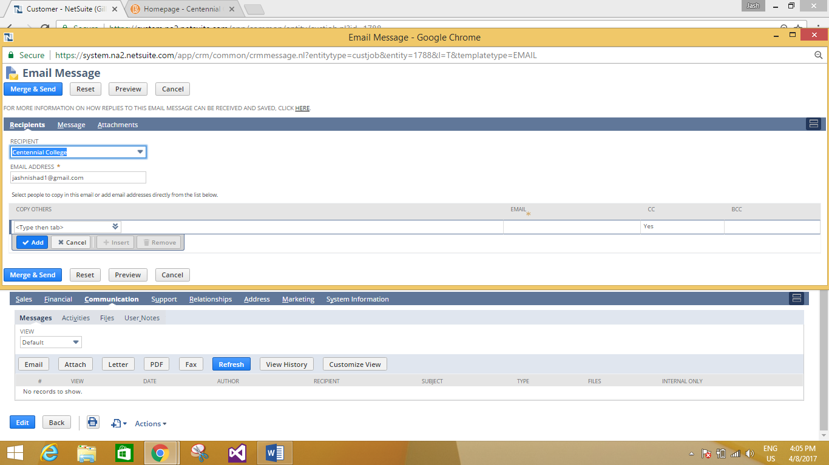

**Customer Support Details.**

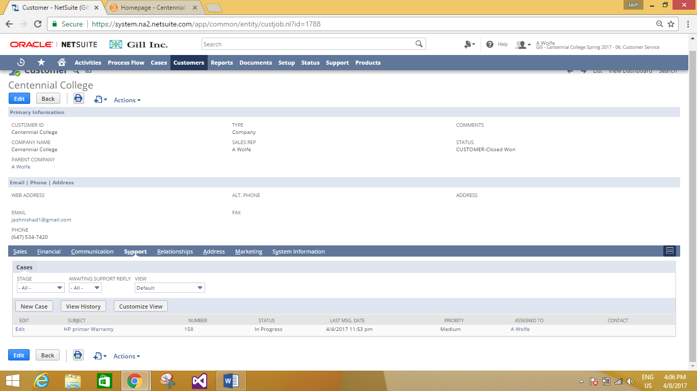

Detailed Replacement Information.

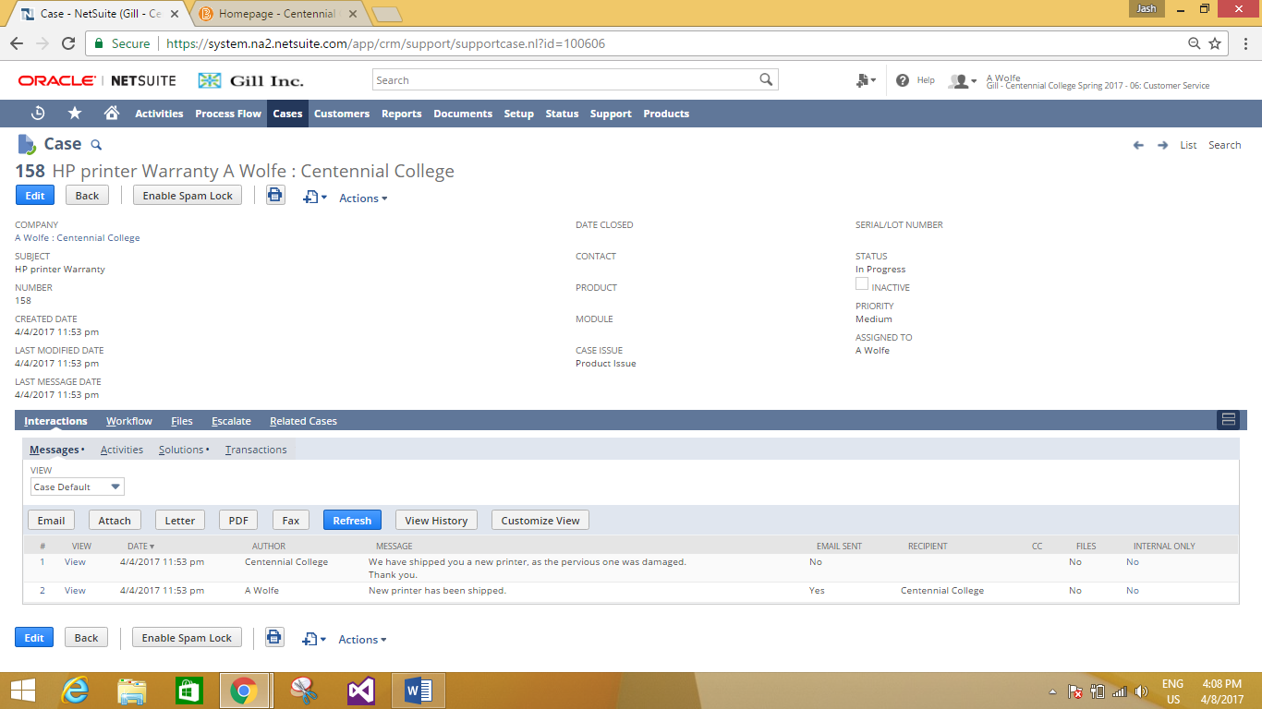

**Message History of the case.**

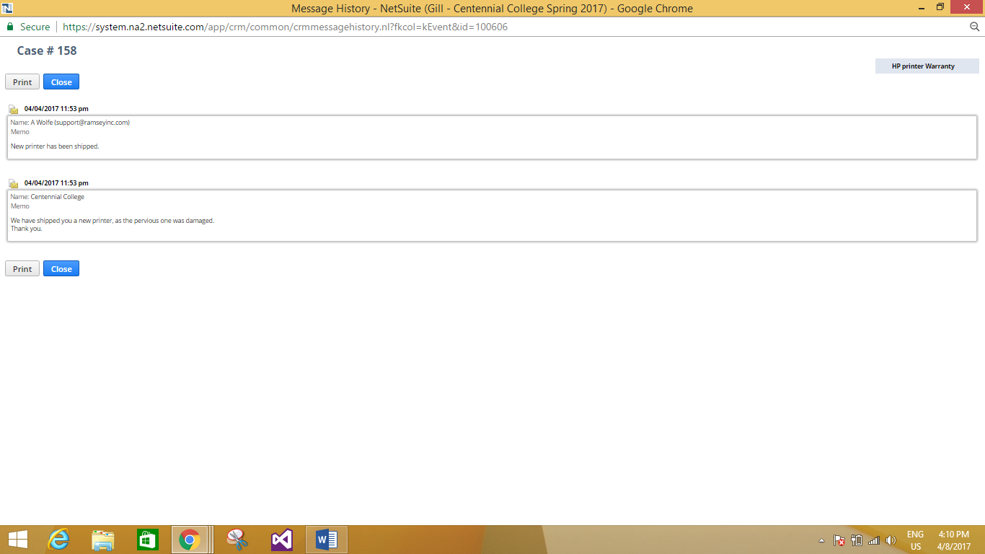

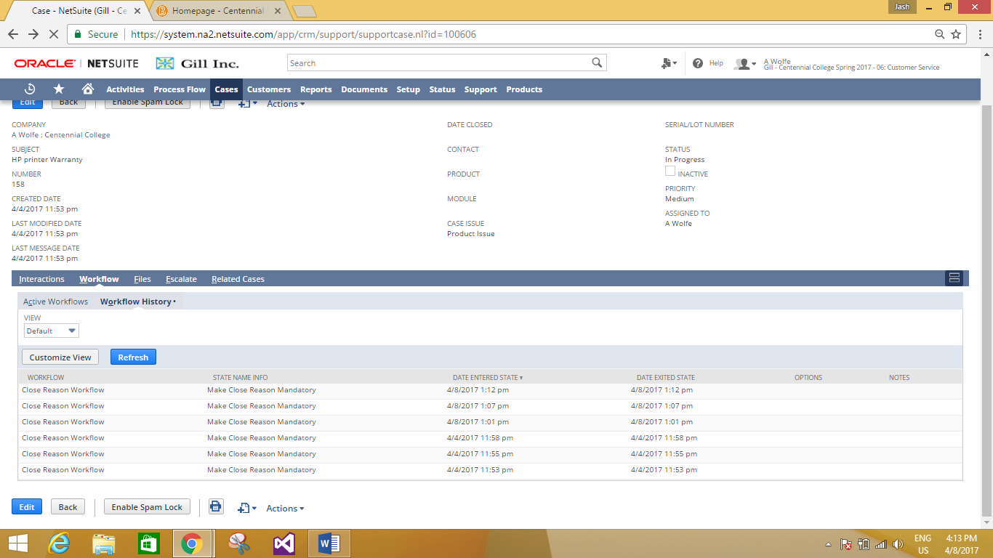

**Case after Editing.**

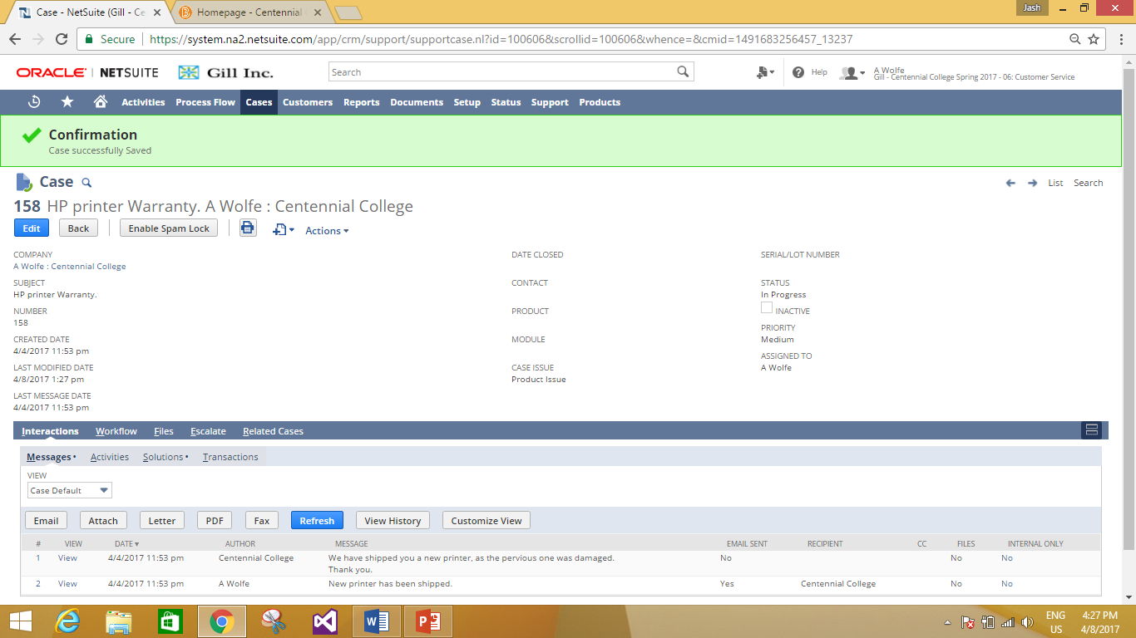

**Adding Promotional Offer Use Case.**

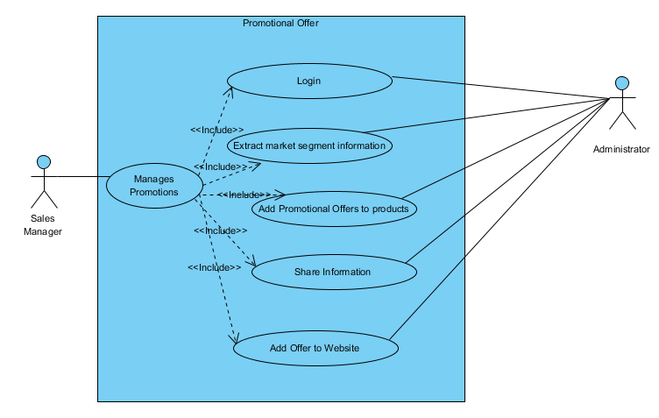

**Work Flow Chart for the Use Case.**

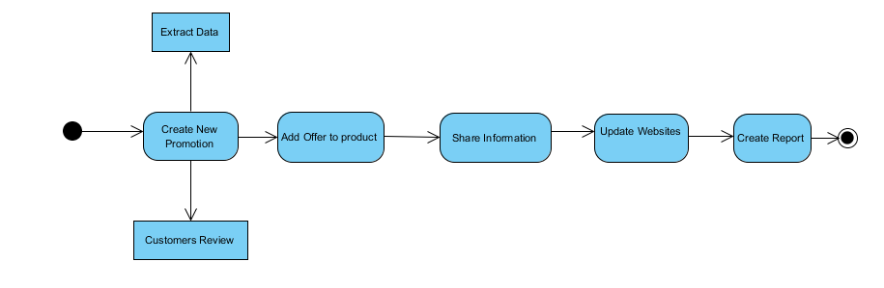

**Primary Information for Adding Promotional Offer.**

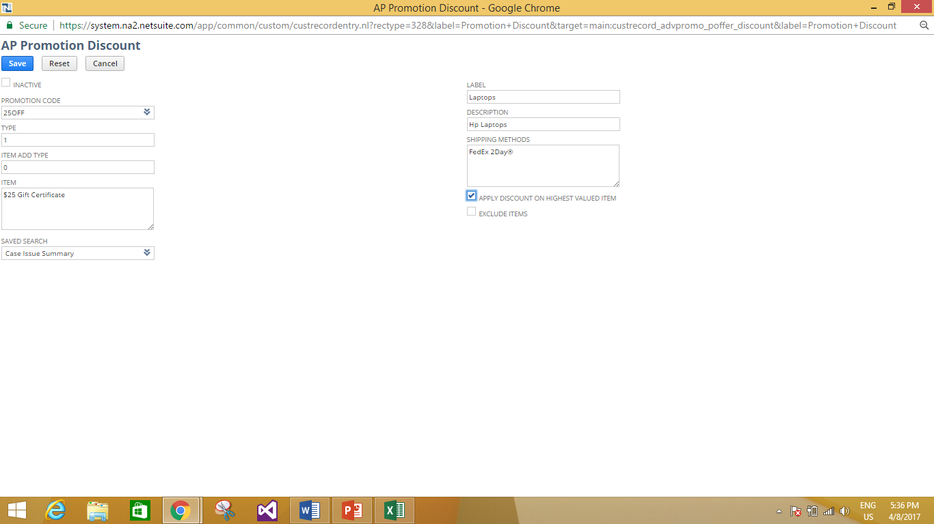

**Adding Detail Information for an Offer.**

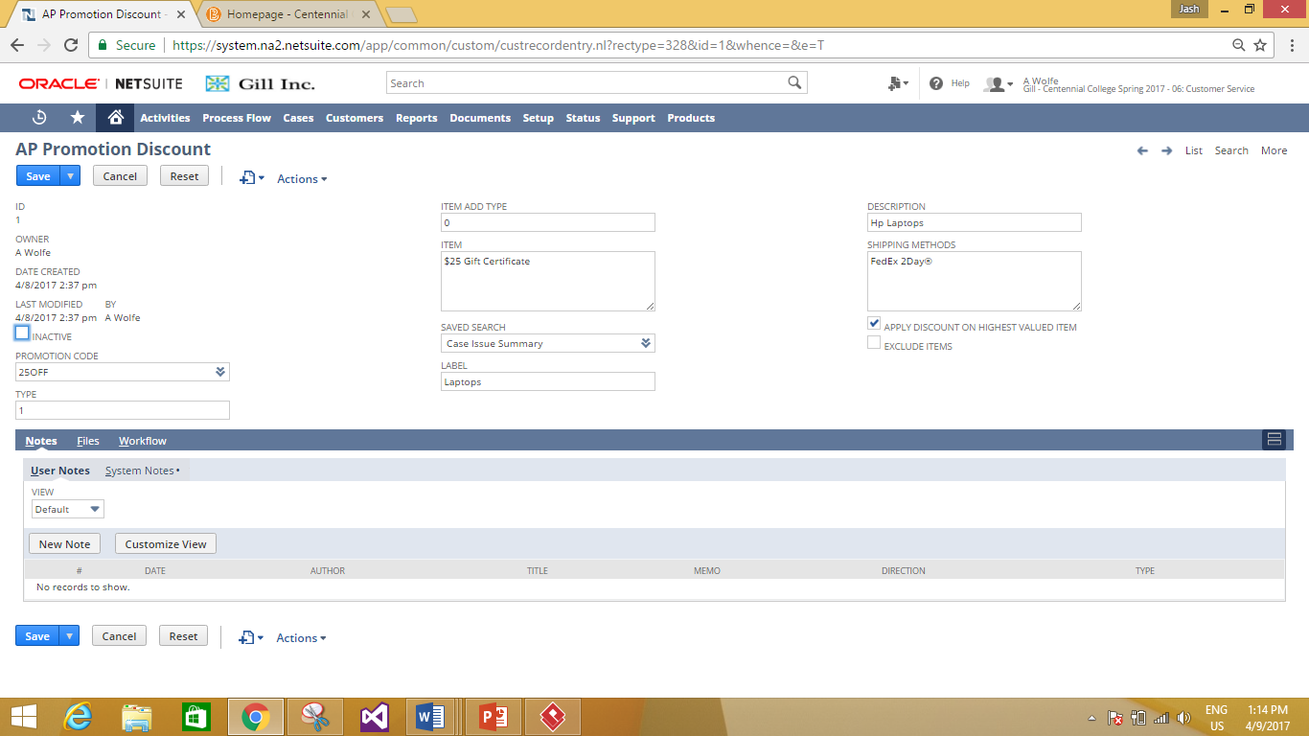

**Completed Information for an Offer.**

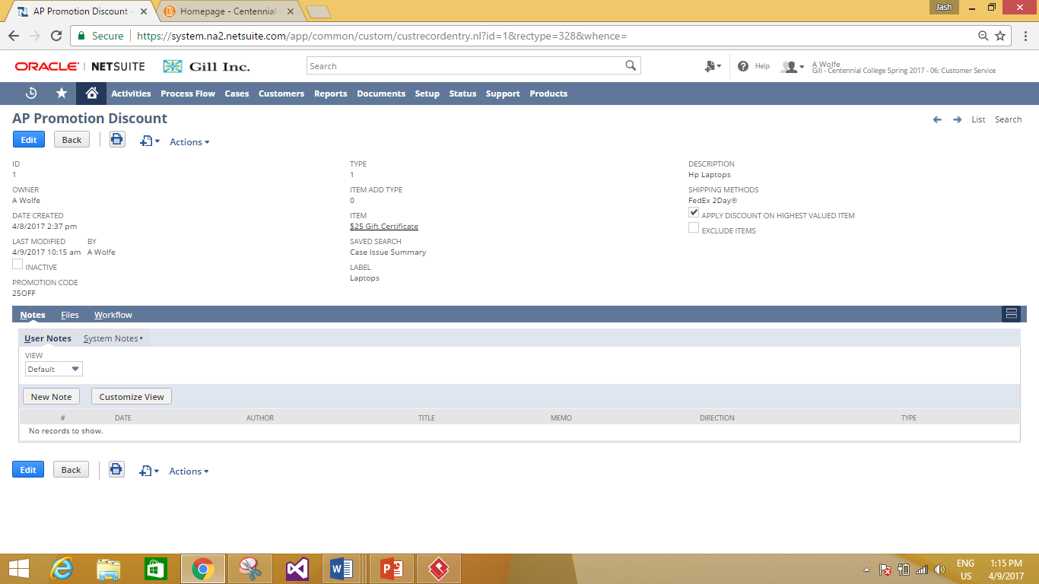

**Creating a Use Case for Organizing an Event or Campaign.**

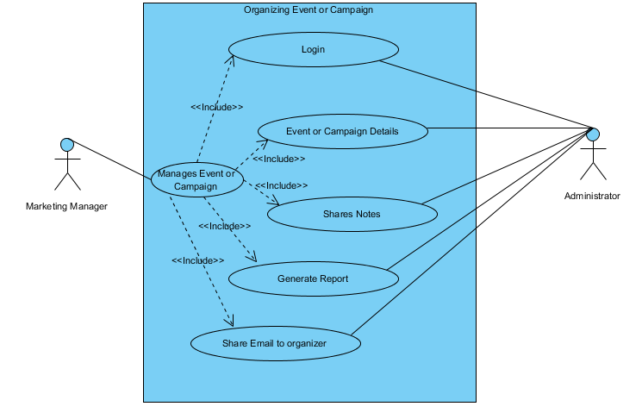

**Work Flow Chart for the Use Case.**

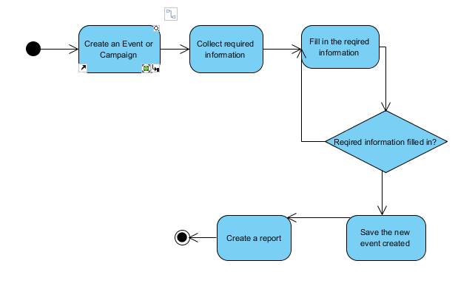

YES

NO

**Creating an Event or Campaign for the use case.**

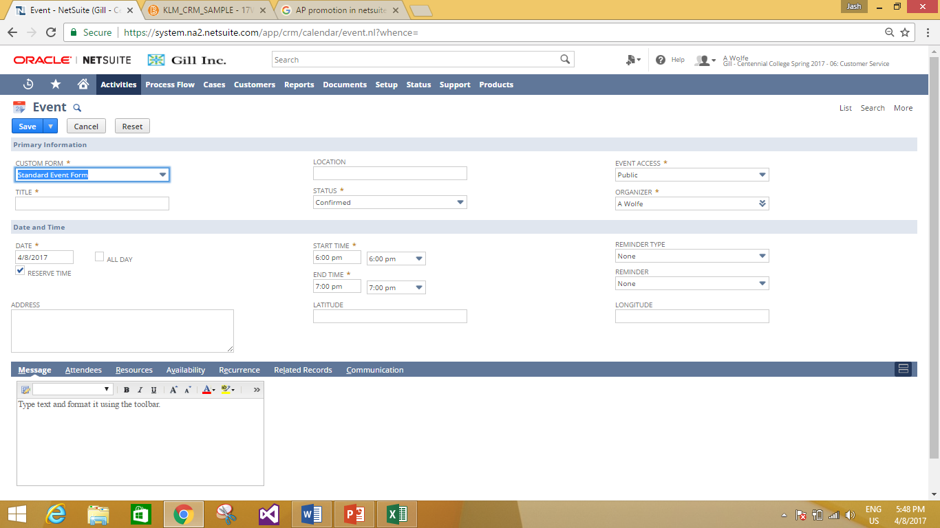

**Filling primary information for the Use case.**

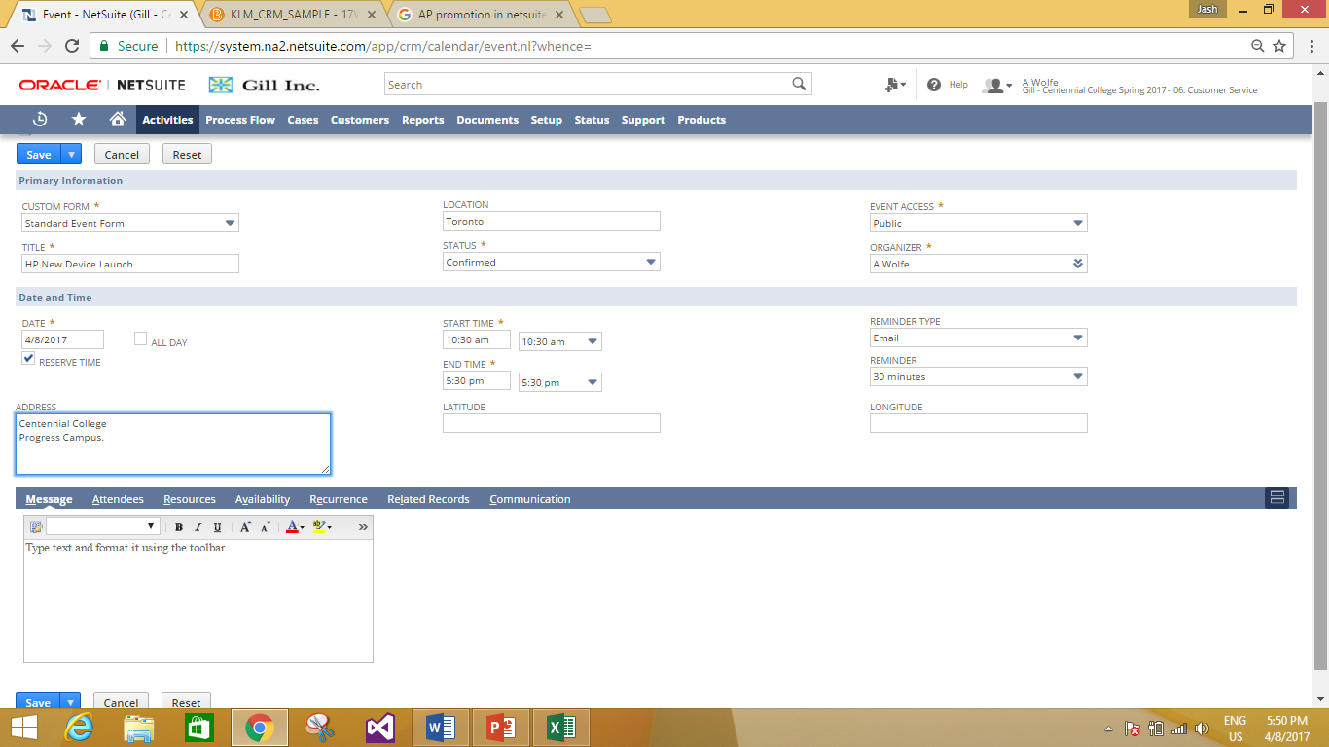

**Confirmation for the completed Event.**

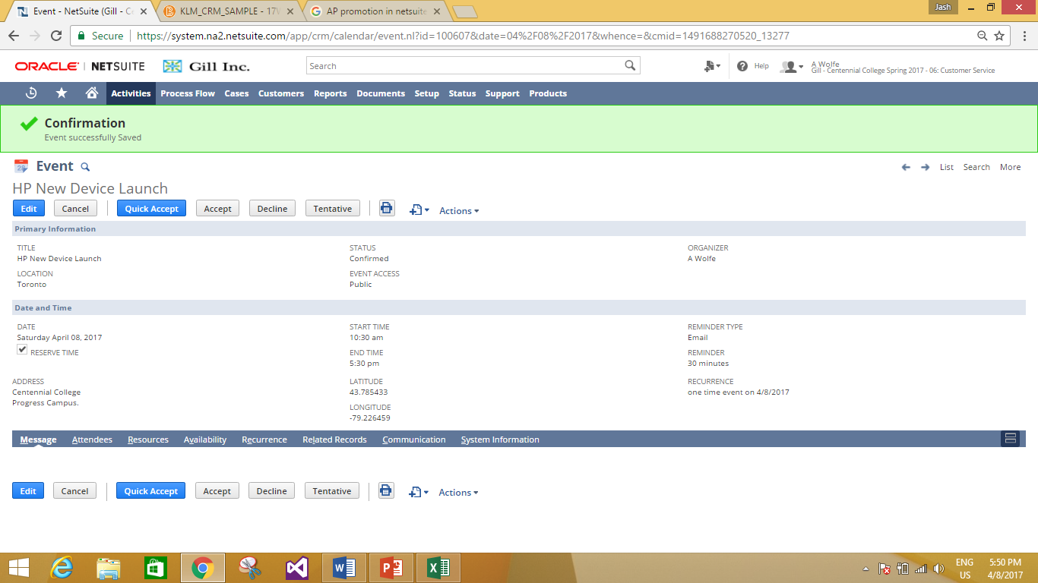

Event Updated.

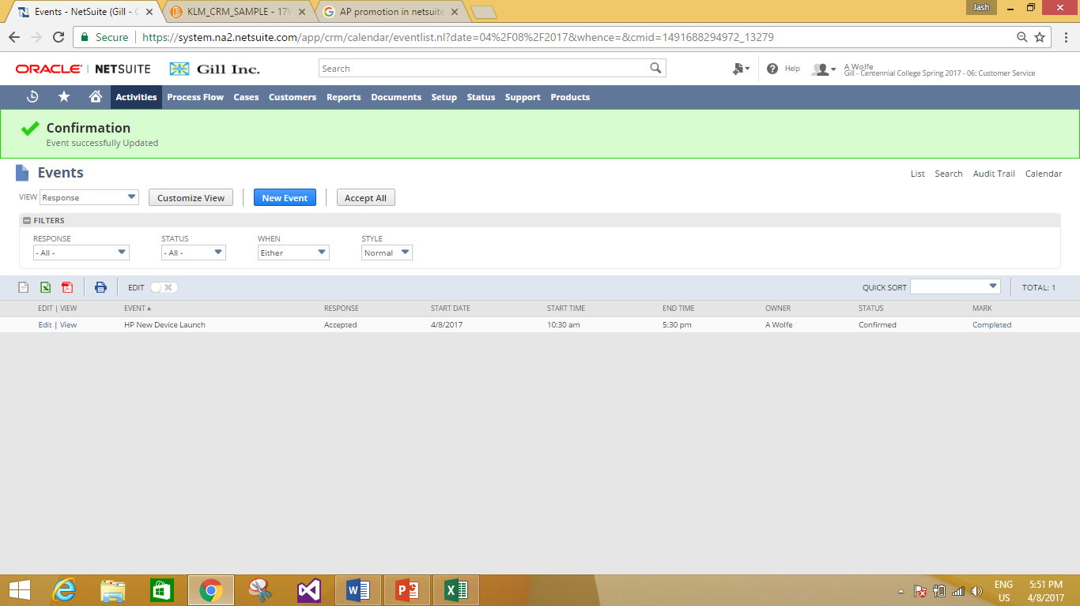

**Event or Campaign Report.**

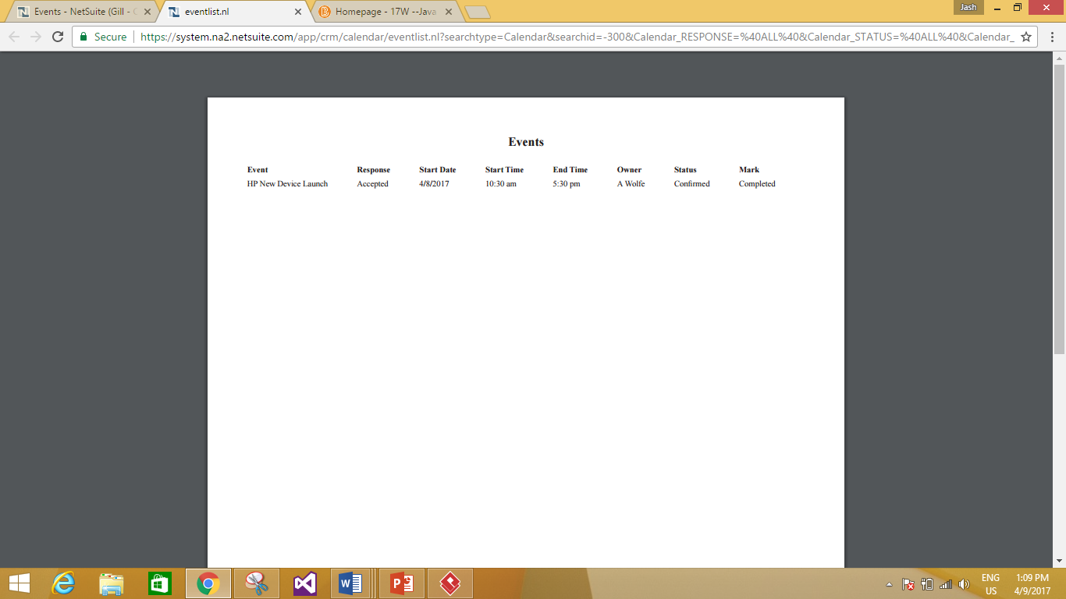

**Capabilities and Benefits of the CRM.**

**Capabilities of NetSuite CRM**

* NetSuite’s Customer Relationship Management (CRM) software is the only cloud solution that delivers a real-time, 360-degree view of your customers.
* NetSuite CRM provides a seamless flow of information across the entire customer lifecycle—from lead all the way through opportunity, sales order, fulfillment, renewal, upsell, cross-sell and support.
* In addition to offering traditional CRM capabilities such as SFA, customer service management and marketing automation, NetSuite CRM delivers quotes, order management, commissions, sales forecasting and integrated ecommerce capabilities.

**Benefits of NetSuite CRM.**

* Streamlines lead-to-cash processes.
* Elevates productivity across the organization with a 360-degree view of customers.
* Improves sales performance through forecasting, upsell and commission management and more.
* Helps you manage global sales and services organizations.

**FIVE additional CRM applications that are popular in the industry.**

* Every CRM solution comes in a different flavor — and at a different price.
* Most CRM solutions include all of that functionality, though cheaper options may only offer bits and pieces. Some software runs on-premises, while other systems operate as cloud-based services and might even run on your phone or tablet.
* **Salesforce**
  + Salesforce.com is an American cloud computing company headquartered in San Francisco, California.
  + Salesforce’s customer relationship management (CRM) service is broken down into several broad categories: Sales Cloud, Service Cloud, Data Cloud, Marketing Cloud, Community Cloud, Analytics Cloud, App Cloud, and IoT with over 100,000 customers.

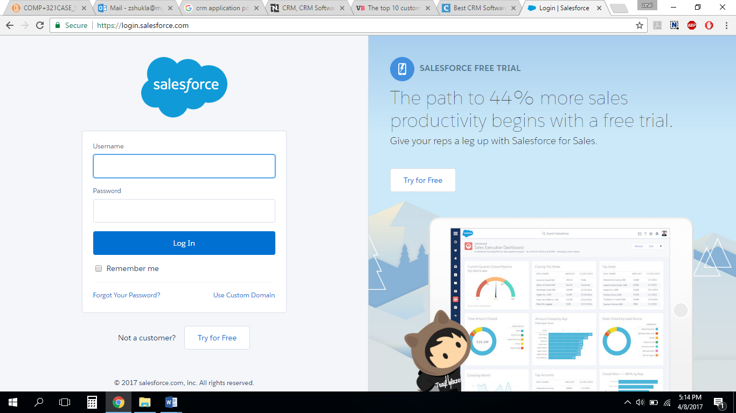

* Have you seen Salesforce's small business solutions lately? SalesforceIQ CRM is an out-of-the-box solution that sets up in minutes and is designed for growing businesses. SalesforceIQ allows sales teams to prioritize and spend time where it matters by eliminating manual data entry and proactively surfacing key insights. Or choose Sales Cloud, a customizable CRM platform that grows with you. Get real-time customer information and activity in one place, plus insights with dashboards and reports.
* Salesforce CRM Provides Easy Access To:
  + Client history
  + Current client preferences
  + Client social media presence
  + Past interactions with a client
  + Client infrastructure details
  + Client social media presence
  + Past sales interactions

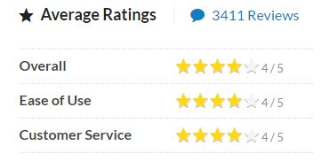

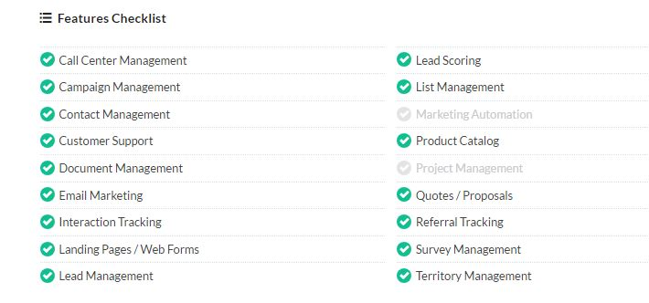

* **Zoho**

Zoho CRM empowers small to large-sized organizations with a complete customer relationship lifecycle management solution for managing organization-wide Sales, Marketing, Customer Support & Service and Inventory Management in a single business system.

**Sales Force Automation:**

Zoho CRM's Sales force automation solution helps you to track leads, prospects, business opportunities and close more deals in less time.

**Marketing Automation:**

With the Zoho CRM marketing automation, you can effectively plan marketing activities, improve the quality of leads generation process.

**Customer Support & Service:**

Zoho CRM's Cases and Solutions functionality empowers you to streamline the organization-wide Customer Support process and enable a better integration between Sales & Customer Support processes in a single system.

**Inventory Management:**

Zoho CRM Inventory Management helps you to achieve the seamless integration between pre-sales and post-sales activities in a single application.

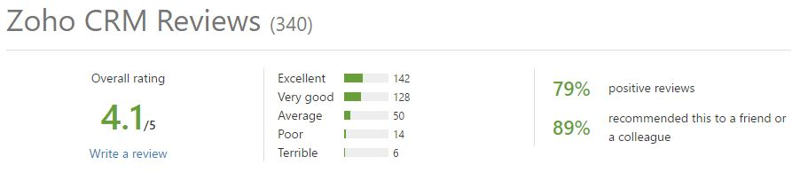

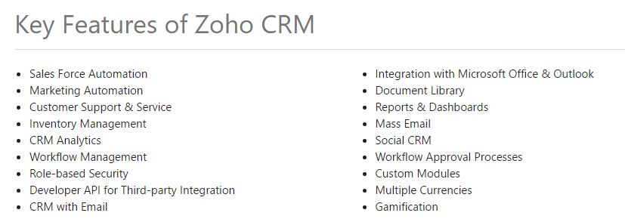

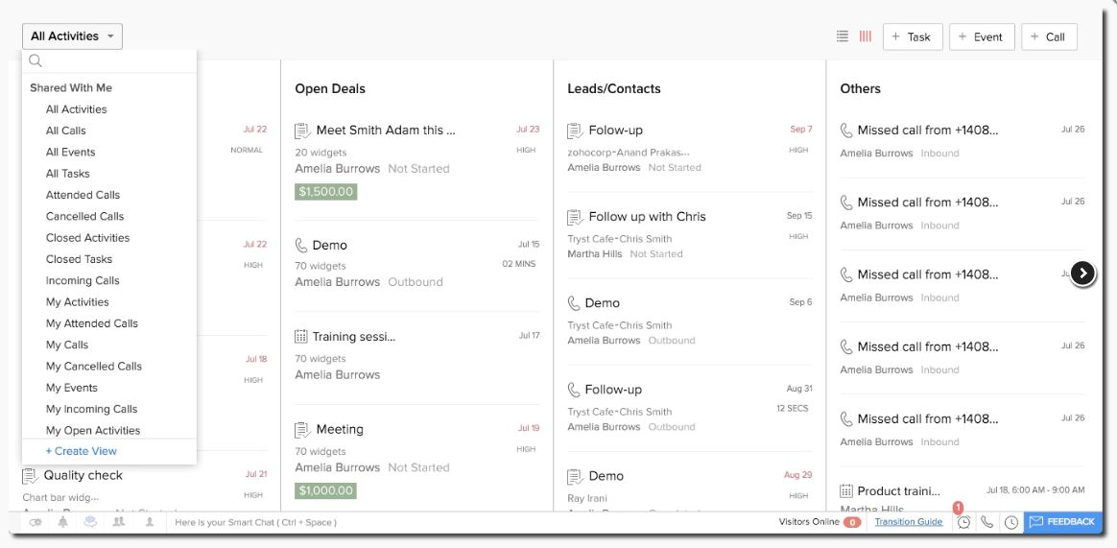

* **Act!**

Act! Is the #1 best-selling Contact and Customer Manager for over 25 years, affordable and easy to use, Act! Is the trusted solution to help individuals, small businesses, and sales teams organize prospect and customer details in one place, market products and services more effectively, and drive sales results - in the office and on the road.

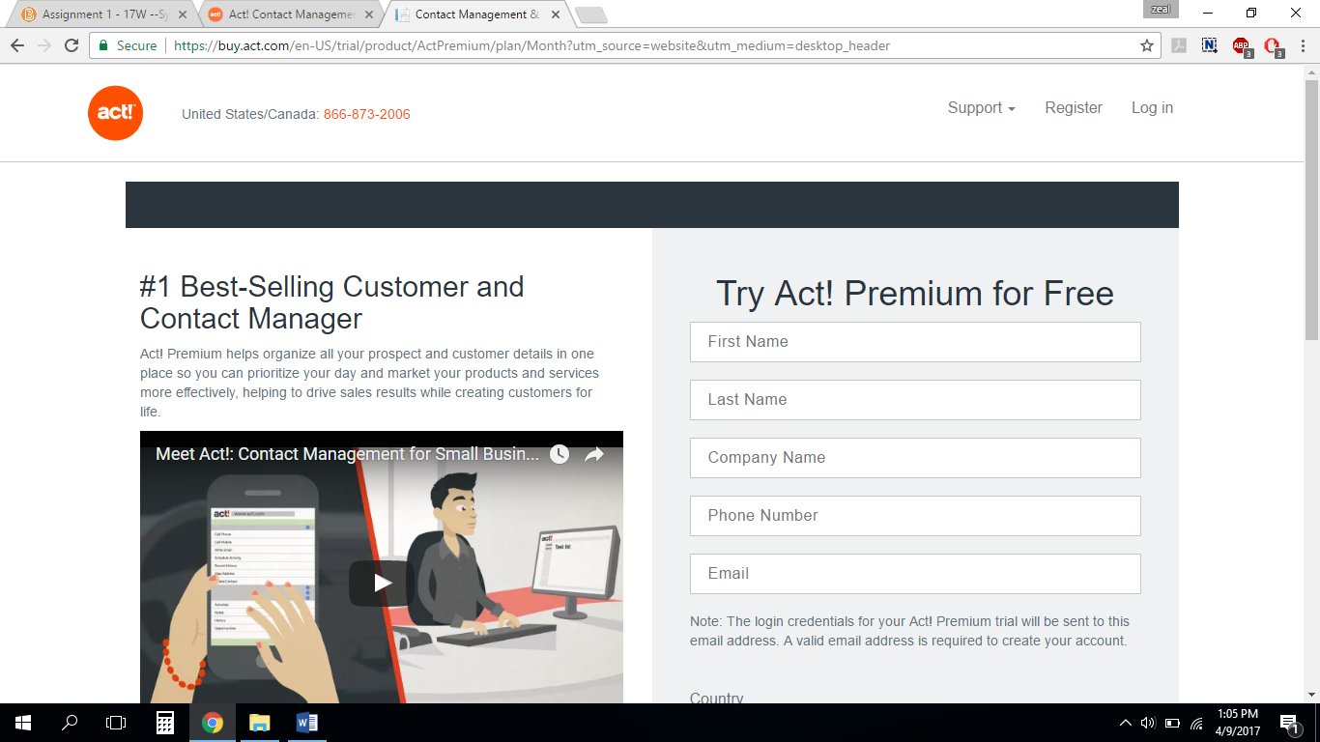

**The Act! Suite of solutions provides:**

* + Expert support
  + Intelligent recommendations
  + Rich integrations with the business tools you rely on every day
  + Ultimate flexibility to meet all of your payment, deployment, and access needs
  + Email marketing - Basic Act! E-marketing included at no additional cost

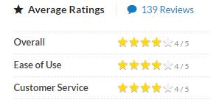

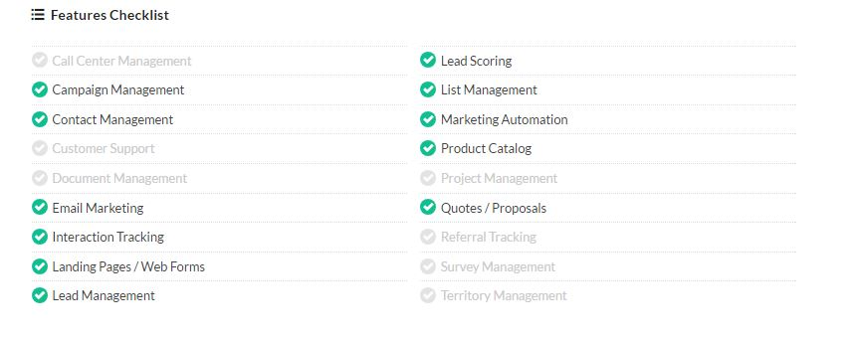

* **Dynamics CRM**

Microsoft Dynamics is a line of integrated, adaptable business management solutions that enable your people to make important business decisions with greater confidence. Microsoft Dynamics works like and with familiar Microsoft software-easing adoption and reducing the risks inherent with implementing a new solution. These solutions automate and streamline financial, customer relationship, and supply chain processes in a way that can help you drive business success.

Dynamics 365 delivers the full spectrum of CRM through five individual apps— Sales, Customer Service, Field Service, Project Service Automation, and Marketing —that work seamlessly together.

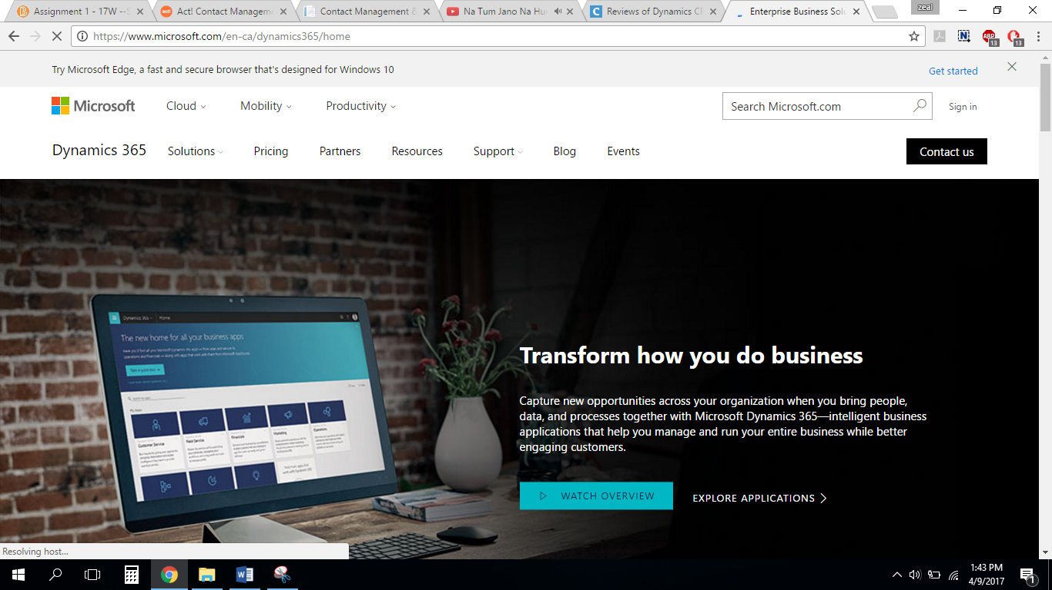

Streamline acquisition, marketing and customer support processes with Microsoft Dynamics CRM.

* Microsoft Dynamics CRM - the customer relationship management solution built for your business
* CRM is a strategy, Microsoft Dynamics CRM helps you achieve it
* Online and offline access

What distinguishes Dynamics CRM from other market offerings?

* Microsoft Dynamics CRM provides choice and flexibility in how you implement and customize your CRM application so you can achieve the best fit for your business.
* Design and automate business processes to unify line-of-business systems with flexible, easy-to-use tools built on the Microsoft Windows Workflow Foundation platform.
* Conduct business globally with full support for multiple languages and currencies across multiple time zones so you can compete globally while keeping costs under control.
* Align IT and business goals with point-and-click customizations, extensible data models, and mapping tools to help build a solution that matches your business and your people.
* Works the way technology should. Built on reliable, industry-standard technology, Microsoft Dynamics CRM is an adaptable and affordable CRM system that can grow and change with your business.
* Realize fast return with industry-standard technology built on a performance-enhanced architecture that gives you fewer elements to deploy and maintain.
* Protect IT investments using flexible technology that does not lock you in and is easy to upgrade, move, and extend into new business groups, geographies, and lines of business.
* Connect to other technologies with built-in integration between internal and external systems, helping to reduce operational costs and provide fast access to functionality.

**HubSpot**

Step into the 21st century with the HubSpot CRM, an easy to use CRM system that eliminates manual work and actually helps your sales team sell. It's free, and you can start using it right now. The HubSpot CRM allows you to keep all your contacts in one centralized, customizable database, automatically logs every interaction for you, and crawls the internet for you, keeping track of over 13M companies (and growing). Best for companies with 10-200 employees.

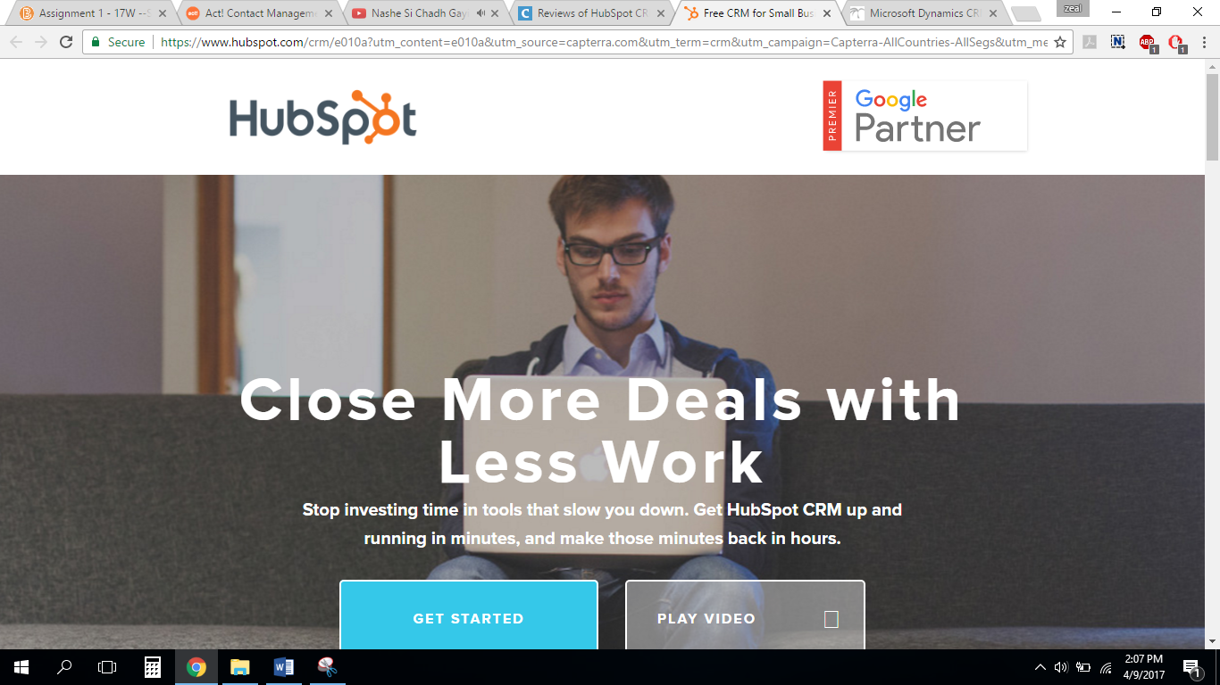

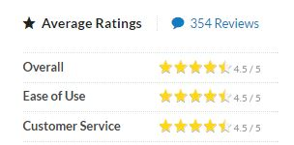

* On its own, the CRM is a totally free way to manage your entire pipeline and contacts database.
* You can keep track of contacts and customer interactions, monitor deals at every stage, and make sure everyone on your sales team is on the same page.

**Deals & Tasks**

Never let a lucrative deal slip through the cracks again. Add deals with a single click, assign tasks to push those deals forward, and track progress in your dashboards.

**Contact Management**

Manage your contacts without the busywork. Add company and contact records with a single click, log sales activities automatically, and easily keep your records up to date.

**Lead Management**

Immediate access to everything you need to manage leads. Complete sales activities, see detailed company and contact records, and view communication history in one convenient place.

**Insights**

Get insights your sales team will actually use. Make calls and send emails from the same place you keep all of your lead and customer data.

**Email Tracking**

Get notified when a prospect opens your email or clicks a link. Email tracking works with Gmail, Outlook, and HubSpot CRM.

**Email Templates**

Turn your best and most repetitive sales emails into templates that you can personalize, optimize, and share with your team.

References.

**N. (n.d.). NetSuite CRM. Retrieved April 09, 2017, from** [**http://www.netsuite.com/portal/products/crm.shtml**](http://www.netsuite.com/portal/products/crm.shtml)

**Hollar, K. (2016, July 07). Best CRM Software | 2017 Reviews of the Most Popular Systems. Retrieved April 09, 2017, from**

[**http://www.capterra.com/customer-relationship-management-software/#infographic**](http://www.capterra.com/customer-relationship-management-software/#infographic)

**Typo3 programming by bytes in motion, www.bytesinmotion.com. (2016, June 22). Microsoft Dynamics CRM: The features of Microsoft Dynamics CRM. Retrieved April 09, 2017, from**

**http://www.wuerth-phoenix.com/en/solutions/crm/microsoft-dynamics-crm/overview/**